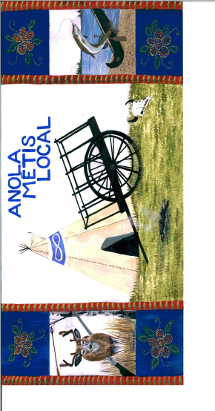

Anola Metis Local
Minutes of Zoom Meeting March 16, 2022
Attendees: Jacqueline Chartrand, Faithe Pearson, Debbie Clague, Jackie Mason, Melanie Mason, Dana Trapp
Jackie Mason, Chair, called the meeting to order at 6:55 pm. Jackie Mason spoke the Opening Prayer
- Minutes of December 19, 2021 were reviewed
- Treasurer’s Report presented by Jacqueline Chartrand. Balance in account $3312.18, which includes $60 petty cash. MOTION #1: That the Local approve payment of a storage space for Local items that could cost $102 plus taxes if a 5’x10’ space is required. 1st Jacqueline Chartrand 2nd Debbie Clague All in favour – Carried. MOTION #2: That Jacqueline submit the yearend report for Local Funding Grant and submit the application for fiscal year 2022-23. 1st Jacqueline Chartrand 2nd Jackie Mason All in favour – Carried. MOTION #3: That Minutes and Treasurer’s Report be adopted. 1st Faithe Pearson 2nd Debbie Clague. All in favour. Carried.
- Storage – Faithe found a storage company called Fort Knox located on Oxford Street within Springfield RM that offered 5x5 space on main floor for $73 or 5x10 space for $102 that is temperature controlled. Rita Vaags will be asked to create an inventory list to be posted in the storage space. Faithe and Jacqueline to follow up with Rita and assist her if required.
- Discussion of Constitutional Ameendments – Jackie reviewed all the proposed amendments. Concern was expressed about Preparation of List of Electors Article V. 3. that stated Preliminary List of Electors was to be posted in at least two public places which are within the geographic boundary of the Local. Jacqueline is to follow up with Chief Electoral Officer David Gray. Review of all the amendments took approximately 45 minutes.
- Upcoming events – Jacqueline will be attending in person the Annual Assembly of Infinity Women’s Secretariat on March 19 at the Fort Garry Hotel in Winnipeg as well as the SE and Interlake Regional meeting in Stonewall on March 20. She will also be attending the MMF AGA on March 25-27. Reports of the assemblies will be presented at the next Local meeting.
- Next Local Meeting – To be held via zoom March 30 from 7:00 – 8:30 pm.
Meeting Adjourned – 8:18 p.m.

