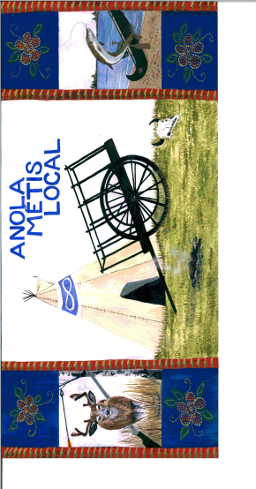
Anola Metis Local
Minutes of Zoom Meeting April 28, 2021
Attendees: Jacqueline Chartrand, Rita Vaags, Faithe Pearson, Rick Mason, Jackie Mason, Irene Carriere, Special guest speaker, Dan Benoit
- Jackie Mason, Chair, called the meeting to order at 7:08 pm. Rita Vaags sang the Metis anthem. Jackie Mason spoke the Opening Prayer.
- Approval of Agenda: MOTION #1: That the Agenda be accepted as amended to include a web site report by Faithe Pearson. 1st Rita Vaags 2nd Faithe Pearson All in favor - Carried.
- Climate Change Presentation by Al Benoit from 7:15 p.m – 8:40 p.m. Dan taught how the expression ‘climate changing’ should really be ‘climate weirding’ as he demonstrated with various graphs and reports on powerpoint just how precariously altered weather patterns have become. He showed historical changes, for instance, in the differing flows of the Assiniboine River over the past few hundred years and how indicative they are of declining amounts of water in the Prairies especially, He says that the Metis traditional homeland will be particularly vulnerable to arid conditions that could become as severe and long lastiing as the dustbowl of the 1930’s. Drought conditions will impact plant and animal life that traditional harvesting depends upon so Metis people should be equipping their homes and properties for such conditions.
- Chairperson’s Report: Due to time constraints, it was decided to forego the President’s report as well as the Minutes of the February 24th meeting as copies had been distributed.
Treasurer’s Report presented by Jacqueline Chartrand. Balance in account $2,873.31, which includes $827.55 in scholarship fund and $60 petty cash. Total Local expenses for this fiscal year so far amount to $1822.16 leaving $677.84 remaining of $2500 advanced by Local Capacity Funding.. MOTION #2: That the Local approve retroactively $310 for the babysitting course kits and facilitation presented by Linda Lamoureux on March 27th. 1st Irene Carriere 2nd Faithe Pearson All in favor – Carried. MOTION #3: That Jacqueline submit the Local Capacity Grant Funding Financial Claim Form identifying 10 expenses that total $1822.16. 1st Rita Vaags 2nd Faithe Pearson All in favor – Carried. MOTION #4: That the Local Executive submit the Local Capacity Grant Funding application for 2021 – 2022. The first payment would be $2500 - $677.84 = $1823.16. 1st Jackie Mason 2nd Rita Vaags All in favor – Carried. MOTION #5: That the Treasurer’s Report be accepted. 1st Faithe Pearson 2nd Irene Carriere All in favor – Carried.

Youth Representative Report: Faithe Pearson had nothing to report at this time other than a missed deadline for a contest.,

Website Update: Faithe sought confirmation about the photo gallery page. She asked if she could start a Twitter account as MMF seems to use it quite frequently. She confirmed that we wanted a Minutes Page as well. The website is well underway. Rita Vaags will access all information passed down from Terry Kolbuck from the previous website and get that info to Faithe as soon as possible. MOTION #6: That the Website Report be accepted. 1st Rita Vaags 2nd Irene Carriere All in favor – Carried

- Planning for 2020-21 fiscal year as well as 2021-22: Jackie Mason has arranged with Jake Freeman to host a 2-part Beading Session on June 2 and June 9 from 7:00 pm – 9:00 pm. She will be contacting members for registrations and order the appropriate number of kits.
- Roundtable: Out of time, the AGA and Bill C-92 reports will be made at the next meeting.
- Next Local Meeting – To be held on May 19, 2021 on Zoom.
Meeting Adjourned – 9:15 p.m.

